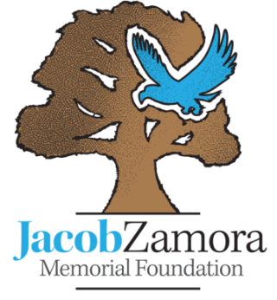

Jacob Zamora Memorial Foundation Scholarship Application
RETURN TO:

Applications to be mailed to the address below:

Jacob Zamora Memorial Foundation
PO Box 3214
Canyon Country, CA 91386-3214
Postmarked by the second Monday in March

RESERVED GPA RANGE: 2.5- 3.4
Please print in blue or black ink only

PERSONAL INFORMATION:
Name____________________________________________________________________ Gender: Male / Female
Last First Middle

Address ___________________________________________________________________________________________
__________________________________________________________________________________________________
Date of Birth ______________________ Email Address_______________________________________________
Phone Number: Home ___________________________ Cell____________________________

SCHOOL INFORMATION:
High School _______________________________________________________________________________________
Name Phone Number

School Address: _____________________________________________________________________________________

*** Please include a copy of your transcript with this application***

PLEASE LIST THE FOLLOWING:
Extracurricular Activities, community service, employment, or other activities.
__________________________________________________________________________________________________
__________________________________________________________________________________________________
__________________________________________________________________________________________________
__________________________________________________________________________________________________
Any significant awards or honors you have received during high school for academic or extracurricular achievement.
__________________________________________________________________________________________________
__________________________________________________________________________________________________
__________________________________________________________________________________________________
__________________________________________________________________________________________________
Essays:
***You must respond to both parts (A) and (B).
A) Tell us about the most difficult time in your life. Explain how your perception of life has changed through the experience, and the impact it has made on you.
B) Where do you see yourself in ten years?

TO BE COMPLETED BY A PARENT OR GUARDIAN
Father/ Male Guardian Mother/ Female Guardian
Name _________________________________________Name _____________________________________________
Relation_______________________________________ Relation _____________________________________________
Occupation ____________________________________ Occupation __________________________________________
Age of applicant’s sibling(s) _______________________ # of children attending college next year _______________
We certify that the information provided is true and complete to the best of our knowledge.
_____________________________________________ _______________________________________________
Applicants Signature Parent Signature

Additional Information:
Please supply an email address if you’d like a receipt of your application.
___________________________________________________________

All application materials must be contained in one packet. Transcripts should not be sent separate. A photograph is optional. Incomplete, emailed or faxed applications will not be considered. We suggest that you keep copies of your application materials. Winners will be posted on our website, www.jzmf.org, after the Senior Recognition Awards are granted. We regret that we are unable to notify non-selected applicants of our decision.

The Jacob Zamora Memorial Foundation Scholarships are reserved for high school seniors in the Santa Clarita Valley, with a 2.5 to 3.4 GPA. Scholarships may be used at an accredited college of the winners choosing.
If you have questions please contact a member of the Scholarship Committee below:
Corrie Malinka
cmjg@att.net

Rebecca Hawkins
(661) 212-4341

Josh Zamora
jzmfscholarship@hotmail.com

